In statistical thermodynamics, we know that a probability of a system having state (**j)** with energy **(E)** in a function of temperature **(T)** and a constant **(k)** in an ensemble will be proportional to:

$$a_{j}=e^{-\frac{E_{j}}{kT}}=e^{-βE_{j}}$$

Where the probability is defined as:

$$p_{j}=\frac{a_{j}}{Σa_{j}}=\frac{a_{j}}{A}=\frac{a_{j}}{Q(N,V,β)}$$

Where **(Q)** is defined as partition function in which where the ensemble defined by several partition functions **(q)** with **(N)** number of particles (note that we use distinguishable particles because of the fact that they can have same energy like a boson):

$$Q={\left[Πq(V,T)\right]}^{N}$$

And we can get the average of energy back by:

$$<E> =Σp_{j}E_{j}=-{\left(\frac{∂\ln\left(Q\right)}{∂β}\right)}_{N,V}$$

Of course, under canonical ensemble N, V, T.

We also can define the heat capacity by using:

$$C_{v}={\left(\frac{∂<E>}{∂T}\right)}_{V}$$

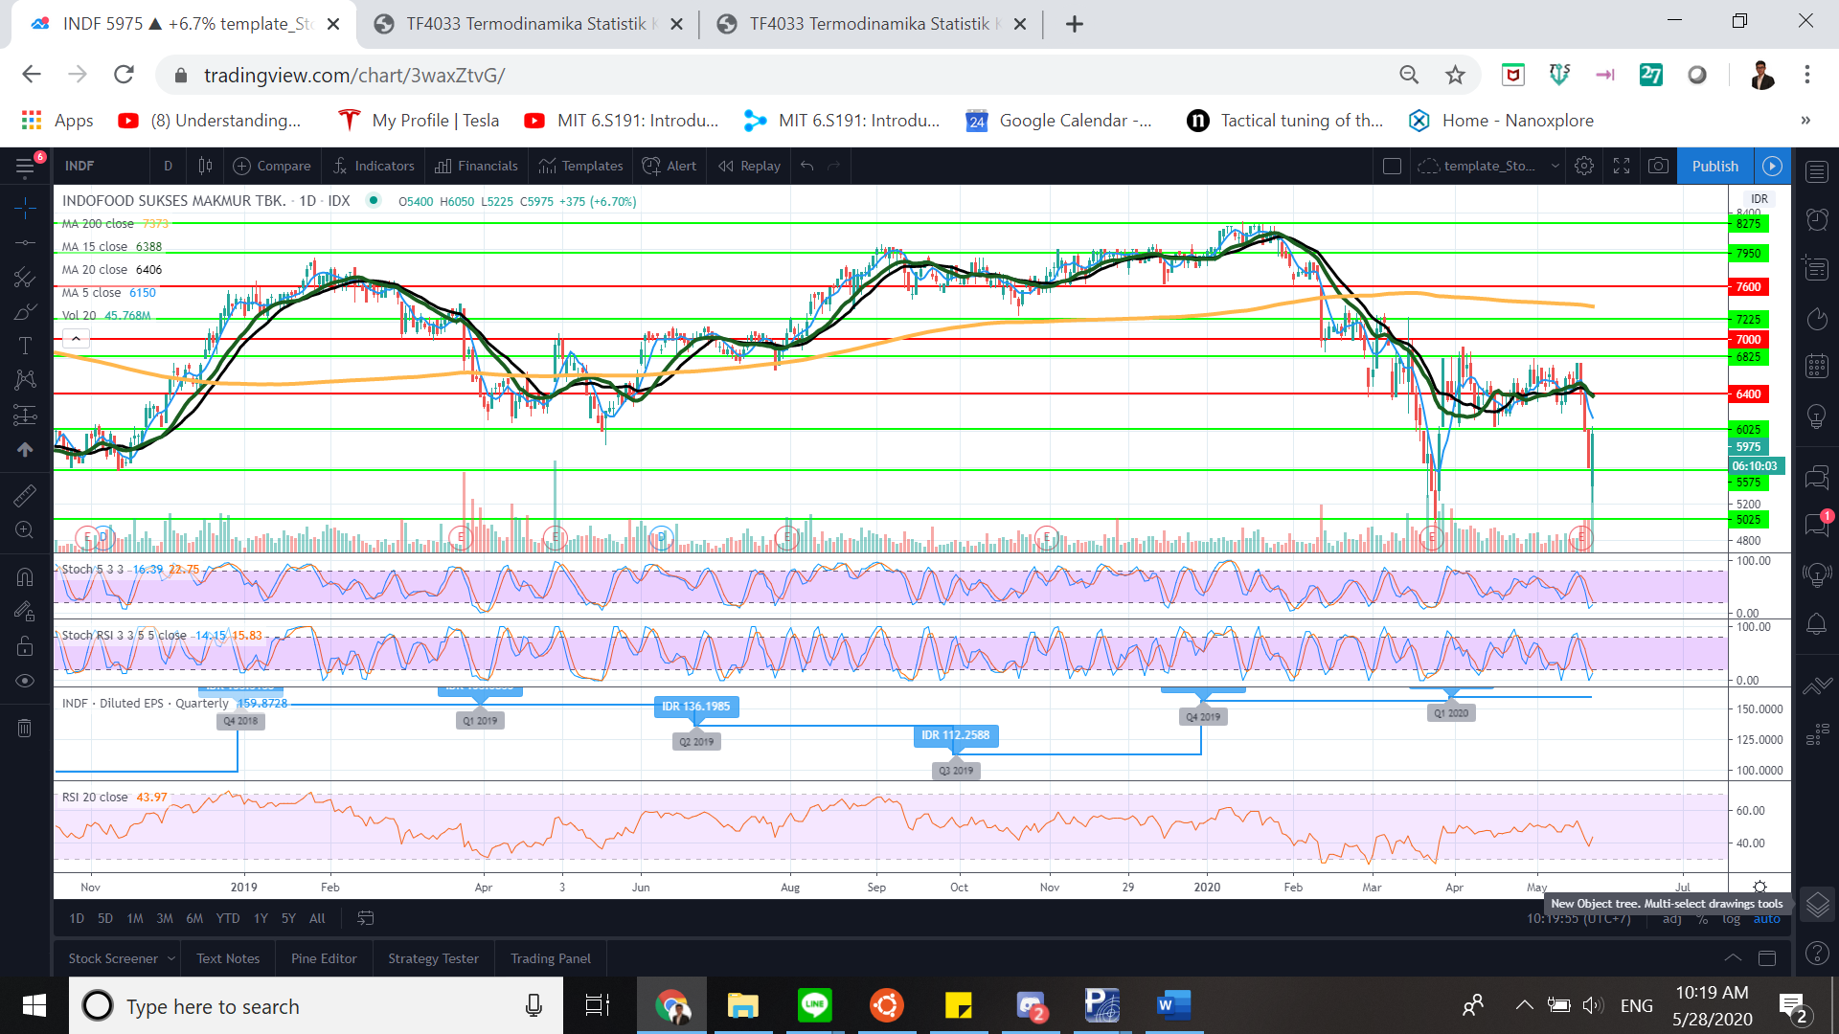

**Figure 1. INDF.JK Historical Price Chart**

If we analyze the stock market price, we could see the same state dependence behavior. For example, take this figure and analyze:

1. We can see that there are several major states where it behaves like a strong “Resistance” or a strong “Support”. But there are also weak spots where it behaves like a weak “Resistance” or a weak “Support”.
2. We can see price as energy quantity such that price per share is analogous to each molecule energy $\left(\frac{<E>}{N}\right)$. We might make hypothesis that these states are dependent due to some **fundamental** parameters (where in molecules we have vibration, rotation, electronic, and translation energies) that are affected by the **state of the company** with the number of particles analogous to shares outstanding amount **(N)** and $β$ analogous to sector condition parameter **($β$)** which is defined using **sector average condition**. The state of the company usually defined by **financial report** **condition**. Therefore, we can see every **company as** **a molecule type** inside an ensemble of N particles homogeneous inert gas inside a chamber with **other companies** which are in the same **sector** with same $β$. These molecules experience pressure **(P)** due to the scarcity of volume **(V)**. Under the assumption of adiabatic chamber, pressure volume is defined by the amount of sector market capital with relation $PV=c$. Where **(c)** is **total sector market capital**. In this model we assume industry doesn’t contribute (negligible).
3. The market moves under influence of enthalpy **(H)** and entropy **(S)** which we will refer as a **process**. The Gibbs Free Energy **(G)** are used to measure the balance of the process. This process balance measurement also depends on $ΔH,ΔS,β, P,V$.

So, we can conclude that (data are written in bold):

1. $\frac{<E>}{N}$ = **Price**
2. Fundamental parameters = **financial report of company** -> states -> state partition function -> partition function for N shares outstanding amount.
3. Sector condition parameter $(β)$ = **sector average condition**.
4. P ~ 1/V = **total sector market capital**.

$H= Δ<E>+PΔV$

$S=$

$G=ΔH-βΔS=Δ<E>+PΔV-βΔS$